**THE FOUR IMPORTANT THEORIES in Optics**

Various theories have been put forward about the nature of light. We will make a brief survey of the four important theories which guided the evolution of our understanding of the nature of light. The theories are known as:

1. Corpuscular theory

2. Wave theory

3. Electromagnetic theory

4. Quantum theory.

**Huygens Principle**

Huygens ' construction is based on the following two fundamental postulates:

***(i)* Every point on a wave front acts as a 'secondary' source. Secondary wavelets spread in all directions from these new sources. The secondary wavelets are spherical and have the same frequency and velocity as the original wave.**

***(ii)* The surface, which touches all the wavelets from the secondary sources, gives the new position of the wave front.**

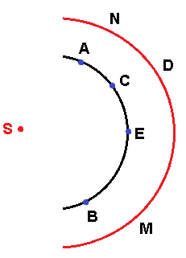

Huygens ' Principle served as very useful guide in explaining the phenomena of interference, diffraction and polarization.

.

**Laws of refraction**

**First Law: The incident ray, the refracted ray and the normal at the point of incidence lie in the same plane.**

**Second Law: The ratio of the sine of the angle of incidence to the sine of the angle of refraction for any two given media is constant.**

 …………(1.1)

**REFRACTIVE INDEX**

**The refractive index of a medium is defined as the ratio of velocity of light in a vacuum to the velocity of light in the medium.**

………………….(1.2)

The absolute refractive index for air under standard conditions is **1.0002918** for light having wavelength of the sodium (589.3 nm).

**Note: The refractive index depends not only on the substance but also on the wavelength of the light. The dependence on wavelength is called dispersion.**

**1.6 OPTICAL PATH**

**The shortest distance, L between two points A and B is called the geometric path.**

From equation (1.2)



Where t and T are the time taken by the light ray in air and in a medium respectively and AB is the optical path.

………………..(1.3)

The above relation means that a light ray takestimes more time to cover the distance AB in a medium.

If a ray of light travels a distance L in a medium of refractive index. In a certain interval of time, then it would travel a greater distance  in air during the same interval of time. Therefore,

Or …………. (1.4)

i.e., **Optical path length = (Refractive index)*(Geometric path length)**

Thus, the **optical path length is defined as the product of refractive index and the geometric path length.**

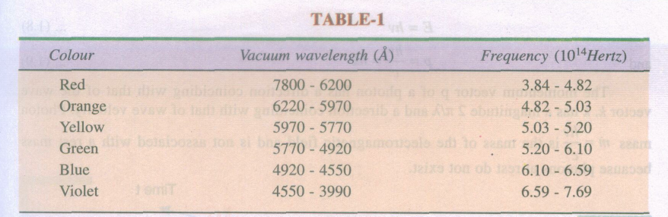

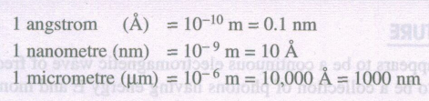

**PHOTONS**

According to quantum theory, light is considered as a stream of special particles, namely photons. Photons do not have rest mass and travel with a velocity equal to the speed of light in a vacuum. The fundamental characteristics of a photon are its energy E and momentum p.

…………………..(1.5)

….….…(1.6)

K is a wave vector has a magnitude  and a direction coinciding with that of wave velocity.

Photon mass  is the mass of the electromagnetic field.

**THE DUAL NATURE**

In view of these developments, light must be regarded as having a dual nature

Light exhibits the characteristics of a wave in some situations and the characteristics of a particle in other situations.

We use all the three descriptions namely **rays, waves and photons** appropriately to describe the behavior of light.

* When light is refracted or reflected by optical elements such as lenses, we mostly use the ray description.
* When light propagates through space or any medium we use the electromagnetic wave description.
* Whenever light interacts with matter we make use of the photon description.

**QUESTIONS**

1. What is meant by reflection?

2. State and explain the law of reflection.

3. What do you mean by refraction of light?

4. What is absolute refractive index of a medium?

5. What is Snell's law?

6. What is meant by optical path? How is it different from geometrical path length?

7. What are the four important theories of light?

8. Describe the Huygens' wave theory?

9. Why light is classified in the category of electromagnetic waves?

11. Explain what the visible region means?

12. What is photon theory of light?

13. Explain the dual nature of light?